Page 1 of 3

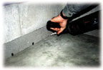
1. Relieve Hydrostatic Pressure
Drill 1/2" or 5/8” weep holes into the cells of each block (Four to six inches in from each mortar-joint ) at the point where the floor and wall meet. Solid poured concrete, brick or stone walls have no cavities, therefore, you don’t drill weep holes.
Video Tip! How to find the hollow cores in your basement walls
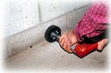
2. Prepare the Surface Properly
To properly bond and seal the system to the concrete floor, the floor area along the wall approximately 3-inch wide must be stripped to bare concrete. To remove all paint or tile adhesive, use a 3M metal paint stripper-wheel with your electric drill. Do not use paint strippers!
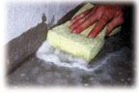
3. Clean the Basement Floor Properly
Important Step! Clean bare concrete floor by washing with clear water and sponge to remove all dirt and dust. When finished feel the area with your fingers for any loose grit left behind. You do not need clean the basement walls, as the SquidGee Dry System is not glued to the walls, allowing any water seepage from the face of the walls to be directed behind the main section.
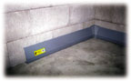
4. Cut and Fit the Baseboard Sections
Now you are ready to cut and trial-fit the main sections along the basement walls.
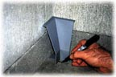
5. Placing Pre-molded Corners
Begin by placing pre-molded corner sections in all the corners. Mark the floor in front of the corners showing where the main sections will stop.
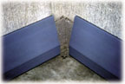
6. Lay Out the System
Place full main sections end-to-end along the wall between the corners marked on the floor. Use tin snips or hack saw to cut main sections as needed. Lay out the SquidGee Dry System just as it will be permanently installed.
Page 2 of 3

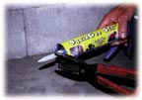
7. SealOnce Adhesive to the SquidDry System!
Angle cut the tip just under the cone shaped end. This will give the large opening needed for applying SealOnce to all surfaces. One tube of SealOnce is needed for each 4-foot 6-inch main section.
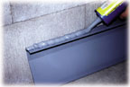
8. Applying Bottom Bead of Adhesive
Important Step! Turn a main section over and apply a tall, thick bead of SealOnce™ to the bottom. Turn main section back over and set in place. Press in place gently for 30 seconds! DO NOT PRESS DOWN HARD...
Homeowner Tip!
Use an Empty Box as a Work Station Tip
Hang the bottom lip of the SquidGee main section on the edge of a box. This holds the section in place and makes apply the SealOnce Adhesive to the bottom of each section very easy. Then you set the main section in place along the basement walls using light pressure. It is very important you do not push down hard on the sections.
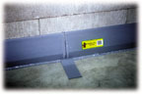
9. Prep Main Sections for Butt-Joints
You will get a much better bond if you use a coarse sandpaper to rough up any vinyl-to-vinyl surfaces. Do this to both sides of the joining baseboards and the butt-joint. Follow sanding by wiping the main section gently free of dust.
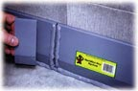
10. Applying Butt-Joints
Apply SealOnce on both sides of the seam. Hook the butt-joint at the bottom and “snap” in place at the top. It’s ok if a butt-joint will not snap perfectly in place. The floor maybe unlevel or baseboards may not line up exactly.
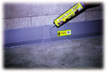
11. Seal Edges of the Butt-Joints
Sealing the edges of the butt-joints and caulking the bottom will insure there are no leaks.
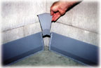
12. Install Pre-molded Corners
Inside corners are easy to install when dropped down from the top. Use a coarse sandpaper to rough up vinyl-to-vinyl surfaces. Apply SealOnce on both main sections and the bottom of the corners.
Page 3 of 3

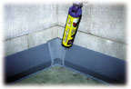
13. Seal Edges of Pre-molded Corners
Seal the corner’s edges and caulk the bottom for a leak-free bond.
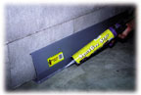
14. Apply Water-tight Finishing Seal
Important Step! Working with one main section at a time, caulk the floor joint with enough pressure to force some SealOnce under the system. Continue immediately to the step below...
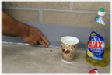
15. Slick Down Finishing Seal to Seal System Water-tight
Important Step! As soon as you caulk each section, using a cornering tool or your fingers, slick down the finishing bead of adhesive. Dip your fingers in liquid soap and slick down the seal. The finishing seal is your water-tight seal.
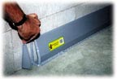
16. Installing End Cap
Apply SealOnce Adhesive across the bottom, up the wall and down the edge of the baseboard. Set end cap in place and caulk all joining surfaces again.
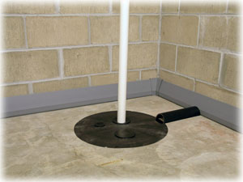
17. Draining SquidGee Dry System
There are two options when draining the SquidGee Dry System. You can drain the system into a Sump Pump or directly into your basement floor drain...
Step 1: Purchase a 2-inch round PVC pipe from your local hardware center.
Step 2: Cut the round PVC pipe lengthwise creating a half-round shape.
Step 3: Glue the opening of the half-round shaped PVC pipe to the floor, directing the water from the SquidGee Dry System into the top the sump pump or floor drain.
Learn more about the Do-it-yourself Sump Pump Kit...
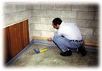
Finish Your Basement
Learn how to finish your basement after installing the SquidGee Dry System.

